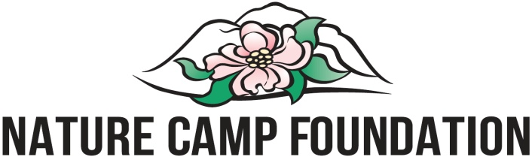 GIFT IN KIND

Please complete our Gift In Kind Form when your gift (or service, if there is no tangible item) is made so that we can accurately record and track donations and to ensure the donor receives an acknowledgment and a receipt necessary for tax deduction.

Donor Name:

(Please list name as you would like it to appear in our Annual Report and donor records.)

Contact Name:

(If applicable, contact within donating organization to whom correspondence should be sent.)

Mailing Address: _________ ____________________________________________________________________

Daytime Phone: Evening Phone:

Description of Gift: ___________________________________________________ ________________________________________________________________________

__________________________________________________________________________

_________________________________________________________________________

*Estimated Value:

Donor Signature: ___________ __________________ _ Date: _________

Please check this box if you wish for your gift to remain anonymous in recognition listings.

*The valuation stated above has been provided by the donor. The property has not been appraised by Nature Camp Foundation or otherwise subjected to an investigation by Nature Camp Foundation as to value and the signature of Nature Camp Foundation on this receipt does not represent concurrence of the appraised value of the contributed property. All items accepted by Nature Camp Foundation will become exclusive and absolute property of Nature Camp Foundation and may be displayed, loaned, retained, or disposed of in the best interests of Nature Camp Foundation. Any appraisal for tax purposes is to be obtained by the donor as Nature Camp Foundation is not permitted to make valuations for tax purposes.

Please return your completed form to:

Nature Camp Foundation, Inc.
P. O. Box 265
Studley, VA 23162

